Rotary Club of Kathmandu Mid-Town
Breakfast Chatter



25 August 2006 The Weekly Bulletin of Rotary Club of Kathmandu Mid-Town Bc # 8 of 2006-07

District : 3290 Web: www.rotarymidtown.org.np Club Id : 26776

AUGUST IS MEMBERSHIP DEVELOPMENT AND EXTENTION MONTH
Without a constant emphasis on membership development, Rotary clubs can not hope to keep pace with the growing need for service or to remain relevant to the needs and interests of Rotary club members. Member-ship in your club must provide value for the club members’ money, time, energy and thoughts (through programs and activities).

Talk Program on Livelihood Perspectives in  Karnali and its women  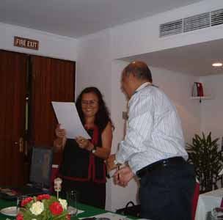  Guest Speaker Dr Sumitra Manandhar receiving a Letter of Appreciation from Club President CK Golchha on Friday morning, 18 August.. | DG visits Kathmandu Midtown  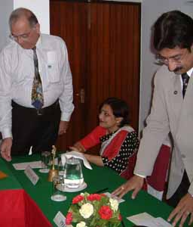  DG Debasish Mitra addressing the Club meeting on 18 August, while First Lady Papiya listening on interestingly and AG Ranjan Kuthari looks on.

Weekly Meetings and Programs
Date | Program/Speaker | Program/Topics of Presentation
25 August 2006 | Bhimarjun Acharya | Making Constitution through Constituent Assembly
1 September 2006 | Anita Giri | My experience with Host families in Germany
8 September 2006 | Pratap Malla | UN Peace keeping mission

Friday, 25 August morning:
Constitutional law expert, Mr Bhimarjun Acharya will be talking to the Club members on different issues of Constituent Assembly and processes for writing the constitution and adopting it.
His presentation will cover the following aspects of constituent assembly:
- a brief of why the new constituion matters
- a brief about the philosophy of constituent assembly
- some instances of the world experiences on CA
- steps and processes on CA
- electoral process on CA
- some challenges
First Lady Papiya

3-H Project : TH-59787
PP Hartmut Bauder’s proposal for a 3-H Grant to help improve reproductive health through training 60 Auxiliary Nurse Midwives, combined with micro-credit for community improvement in Nepal is on track. The total amount being requested is $320,000. The application process is long and final approval will not be granted until the fall, but as of this date there is every sign that approval will be granted. Mid-Town’s international partner is the Rotary Club of Darmstadt-Bergstrasse, District 1860.

Inter-City Meeting
The first Rotary ICM of the year 2006-07 is being hosted by Rotary Club of Kathmandu Mid-Town on Sunday, 27 August 2006. The venue is Nuptse Hall, Birendra International Conference Center, Baneswor. The theme is Membership Development and Retention.
The ICM is going to be addressed by DG Debasish Mitra and other district officials. President of four clubs would be sharing their experiences and their problems in keeping their clubs effective in membership development and retention.

PP Arun M Sherchan's advice

Want to be double sure that you don’t get yourself wet
while walking through monsoon rain ? Look for this
special umbrella at the Japanese shoppig mall !

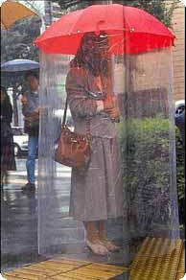

A friendly advice
Bob: Your future depends on your dreams !
Keith: You're right, I'm gonna sleep !

As a Rotary leader, I ask you to Lead the Way in your business and professional life, in your every contact with your community. Make sure that your community unfailingly sees Rotarians acting only with honesty, generosity, courtesy, and good grace.
RI President William B. Boyd

25 August 2006 The Weekly Bulletin of Rotary Club of Kathmandu Mid-Town Bc # 8 of 2006-07

Editor: RR Shrestha, Club Service Director email: rryes@wlink.com.np

